**NAME: SHOAIB ZAMAN**

**JAWAN PAKISTAN FLUTTER COURSE**

**ASSIGNMENT NO 3**

**QUESTION NO 1:**

Take 4 integer variables for subject & create a program for Marksheet that will print user total marks & percentage as well by using concatenation:

SOLUTION:

CODE:

void main() {

int totalmarks = 400;

int english = 60;

int urdu = 75;

int math = 85;

int com = 70;

int obtainedmarks = (english+urdu+math+com);

print("your obtained marks is; ${english+urdu+math+com}");

print("your total marks is : ${totalmarks}");

num percentage=(obtainedmarks/totalmarks*100);

print("Your percentage is; ${percentage}%");

}

**OUTPUT:**

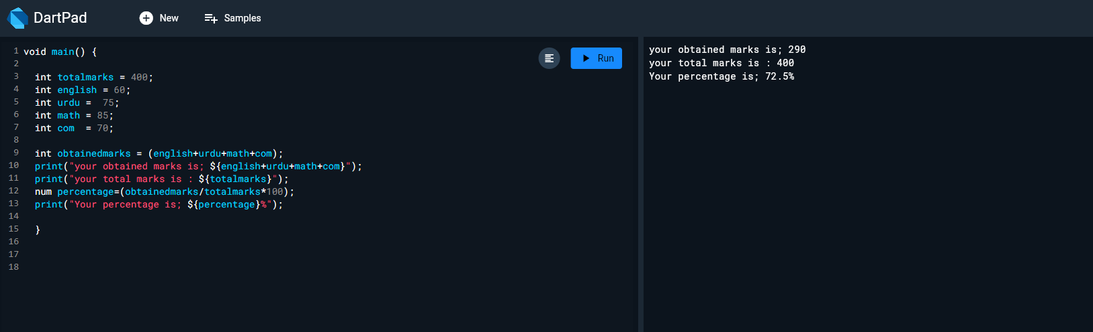

**QUESTION NO 3:**

Length and breadth of a rectangle are 5 and 7 respectively. Write a program to calculate the area of the rectangle.

Formula (area = length * breadth)

SOLUTION:

CODE:

void main () {

int length = 5;

int breadth = 7;

int area = (length*breadth);

print ("area of the rectangle is; ${length*breadth}");

}

**OUTPUT:**

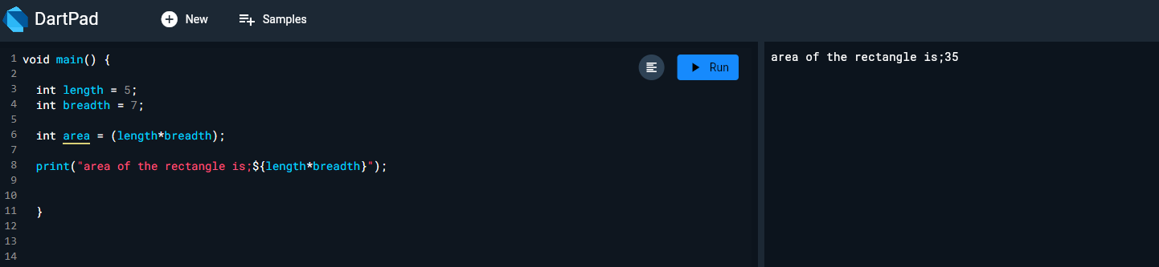

**QUESTION NO 4:**

Create a integer variable num = 7, Add 8 to the number and then divide it by 3. Now, the modulus of that number is taken with 5 and then multiply the resultant value by 5, store result in variable i. Display the final result.

SOLUTION:

CODE:

void main() {

int num1 = 7;

int num2 = 8;

int num3 =num1+num2;

print("Adding is:${num3}");

int num4 = num3*5;

print("Mulitiplication is:${num4}");

double num5 = num4/5;

print("Division is:${num5}");

double i = num5;

print("The final result is;${i}");

}

**OUTPUT:**

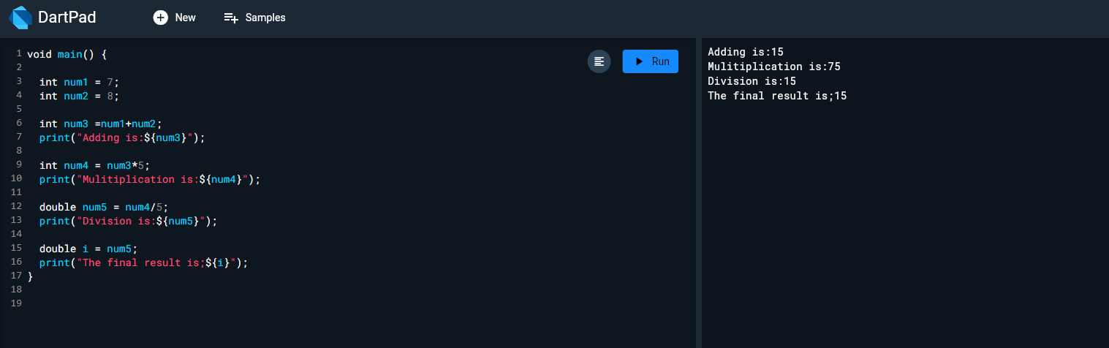

**QUESTION NO 5:**

Write a program create two integer variables 'a' and 'b' and assign them any number and then check if both the conditions 'a < 50' and 'a < b' are true. Display the result, now check if at-least one of the conditions 'a < 50' and 'a < b' is true.

SOLUTION:

CODE:

void main () {

int a = 40;

int b = 45;

print(a<50);

print(a<b);

}

**OUTPUT:**

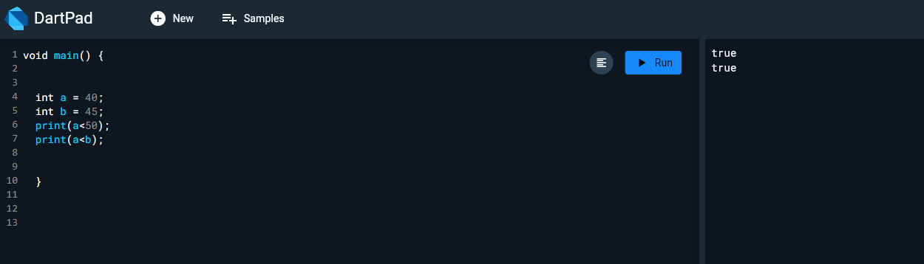

**QUESTION NO 6:**

If the marks of Robert in three subjects are 78,45 and 62 respectively (each out of 100 ),

write a program to calculate his total marks and percentage marks. Print his name, marks of all three subjects, total marks and percentage

SOLUTION:

CODE:

void main() {

int totalmarks = 100;

int sub1 = 78;

int sub2 = 45;

int sub3 = 62;

int obtainedmarks = (sub1+sub2+sub3);

print("Hello Robert Wellcome to your marksheet");

print("Robert Obtained marks of all three subjects are ;${sub1+sub2+sub3}");

print("Robert total marks of all three subjects are ;${totalmarks}");

num percentage =(totalmarks/obtainedmarks *100);

print("Robert percentage is;${percentage}%");

}

OUTPUT:

